Max Shi  
Professor De Rosa  
E 234  
September 14, 2020  
I pledge my honor that I have abided by the Stevens Honor System.  
Partner: Ashley McDermott

1.

|  |  |  |  |  |
| --- | --- | --- | --- | --- |
| QUANTITY | SYMBOL | GIVEN VALUE | SI VALUE | SI UNITS |
| Density | ρ | 120 lbm/ft­3 | **1.92 g/cm3** | **g/cm3** |
| Thermal Conductivity | k | 170 Btu/(hr.ft.F) | **294 W/mK** | W/mK |
| Convective heat transfer coefficient | hconv | 211 Btu/(hr.ft2.F) | **1198 W/m2K** | **W/m2K** |
| Specific heat | cp | 175 Btu/(lbm.F) | **733 kJ/kg⋅°C** | **kJ/kg⋅°C** |
| Viscosity | µ | 20 centipoise | **0.02 Pa⋅s** | Pa⋅s |
| Viscosity | µ | 77 lbf.s/ft2 | **1.608 Pa⋅s** | **Pa⋅s** |
| Kinematic Viscosity | v | 3 ft2/s | **0.279 m2/s** | **m2/s** |
| Stefan-Boltzmann Constant | σ | 0.1713 x 10-8 Btu/(ft2.hr.R4) | **5.6704E-08 W/m2K4** | W/m2K4 |
| Acceleration | a | 12 ft/s2 | **3.658 m/s2** | **m/s2** |

2. His mass is 210 lbm, or 95.5 kg on the Earth. His weight on the moon would be 35.79 lbf, or 159.2 N.

3. A hot water radiator can be considered to be a closed system, because it only releases energy (heat) into its surroundings, and not mass.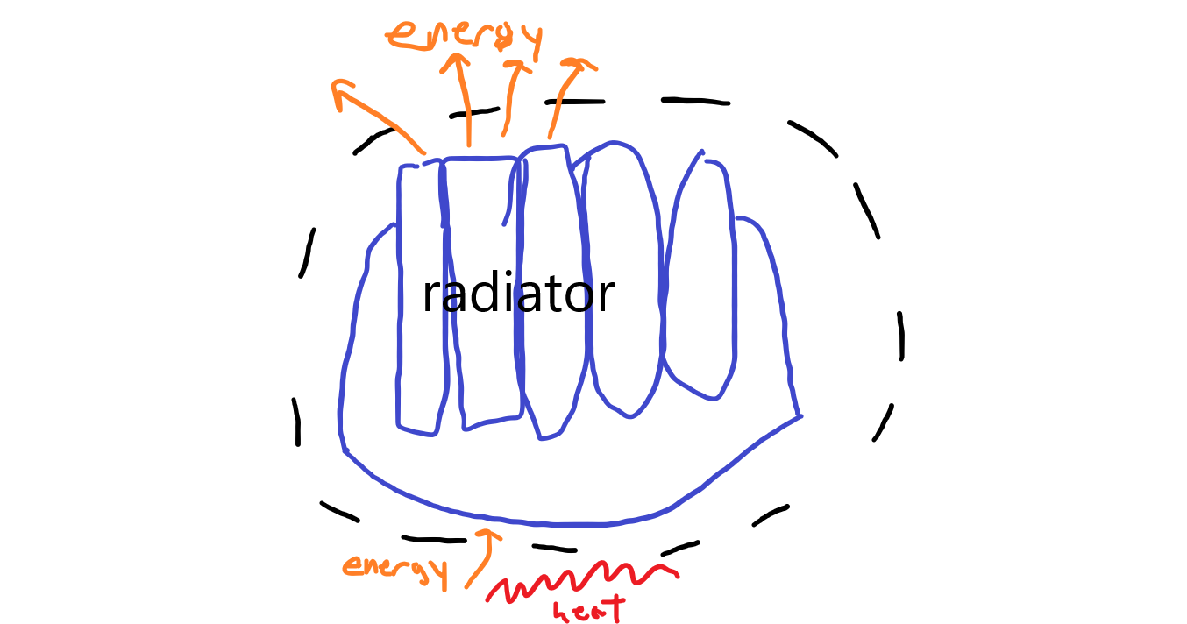

4. The state postulate states that the state of a simple, compressible system is completely specified by two independent and intensive properties. It allows us to use two properties to fully describe a thermodynamic system, as using those two intensive, independent properties, we can calculate all other properties of the system.

5.

|  |  |  |
| --- | --- | --- |
| Variable | Intensive | Extensive |
| Pressure | X |  |
| Dynamic Viscosity | X |  |
| Mass |  | X |
| Length |  | X |
| Volume |  | X |
| Specific Volume | X |  |
| Temperature | X |  |
| Bulk Modulus | X |  |
| Melting Point | X |  |
| Momentum |  | X |

6.

|  |  |
| --- | --- |
| Given Temperature | Temperature (K) |
| 27°C | 300.15 K |
| 0°F | 255.37 K |
| 488 R | 878.4 K |
| -12°F | 248.71 K |
| -273.15°C | 0 K |

7. This is 10 R, 5.56 K, and 5.56°C.

8.

57.5 ft = 17.53 m

Gage pressure = pgh = 1000 kg/m3 * 9.81 m/s2 * 17.53 m = 171930 Pa = 24.9 psi

Absolute pressure = gage + 1 atm = gage + 101325 Pa = 273255 Pa = 39.6 psi

9.

Gage pressure = 26 m * 9.81 m/s2 * 1000 kg/m3 = 255060 Pa

Absolute pressure =

gage pressure + air pressure + atmospheric pressure =

255060 Pa + 250000 Pa + 101325 Pa = 606385 Pa